**POLYTECHNIC UNIVERSITY OF THE PHILIPPINES**

**COLLEGE OF ENGINEERING**

**COMPUTER ENGINEERING DEPARTMENT**

TOTAL QUALITY IN COMPUTER ENGINEERING

Whistle Flashlight for Emergency Survival Tool

PROJECT CHARTER

DOCUMENT

Section BSCOE 5-1D Group No. 3

|  |  |  |  |
| --- | --- | --- | --- |
| **NO** | **MEMBERS (Alphabetical Order)** | **CRITERIA** | **GRADE** |
| 1 | Cagomoc Niña Jaira Lael | Document Format Consistency (20%) |  |
| 2 | Calilung, Kristal |
| 3 | Kitts, Johndell | Problem Statement (20%) |  |
| 4 | Macatangay, senon jayson |
| 5 | Tan, Frederick | Project Goal (20%) |  |
| 6 |  |
| 7 |  | Scope and Benefits (20%) |  |
| 8 |  |
| 9 |  | Timeline (20%) |  |
| 10 |  |
|  |  | **FINAL GRADE** |  |

Instructor

**DR. LUTZ REYES**

2022

1. **CHANGE RECORD:**

|  |  |  |  |
| --- | --- | --- | --- |
| **Date** | **Author** | **DocVer** | **Change Reference** |
| 04-27-2022 | * Cagomoc Niña   Jaira Lael   * Calilung, Kristal * Kitts, Johndell * Macatangay senon jayson * Tan, Frederick | Version  1.0 | Initial Draft |
| 05-31-2022 | - Kitts, Johndell S. | V2 | Budget |
| 05/31/2022 | - Cagomoc, Niña Jaira B | V2 | **Production Plan** |
| 05-31-2022 | - Tan, Frederick | V2 | Timeline |
| 05-31-2022 | - Calilung, Kristal | V2 | Marketing Introductory, Revision of Hard Benefits and soft Benefits |
| 05-31-2022 | - Macatangay, senon jayson | V2 | Gantt Chart |
|  |  |  |  |
|  |  |  |  |
|  |  |  |  |
|  |  |  |  |
|  |  |  |  |
|  |  |  |  |
|  |  |  |  |
|  |  |  |  |
|  |  |  |  |
|  |  |  |  |
|  |  |  |  |
|  |  |  |  |
|  |  |  |  |
|  |  |  |  |
|  |  |  |  |
|  |  |  |  |

1. **PROBLEM STATEMENT: (***Problem or opportunity the project will address. How often does it occur? How do we know it is a problem? What is the impact of the problem?)*

🡨Margin starts here

The Philippines is a Southeast Asian archipelago. It is a group of around 7,640 islands located in the western Pacific Ocean. Thus, natural calamities are a common disaster in our nation. Typhoons, flooding, landslides, earthquakes, and volcanic eruptions are all natural disasters in the Philippines. Heavy rains, which could continue for five to seven days, are expected, potentially causing flooding and landslides. And in these calamities that many people that have died. Many people could have been potentially survived if they have only a tool that will signal the rescuers that they are still alive and trapped because of these calamities. A simple tool that could potentially help save many lives in times of these events.

1. **PROBLEM GOALS:** *(What will be accomplished “MEASURABLE”? Example: To improve the Project from [baseline capability] to [target capability] by [target date])*

🡨Margin starts here

Our Goal is to develop A simple tool that could potentially help save many lives in times of Natural Disasters, Emergencies and Potential Danger. A simple tool that is portable, reliable and effective. A simple tool that can be easily mass produce and cheap for everyone can have.

1. **SCOPE:** *(Boundaries, constraints, restrictions or limits)*

🡨Margin starts here

Our product intends to provide assistance to people in times of need. Typhoons, landslides, earthquakes, and volcanic eruptions are among the natural disasters that require immediate action. It's compact and lightweight, so you can take it with you everywhere you go. Our invention serves two purposes: it may be used as a flashlight, which is a more convenient and safe alternative to using a candle stick. A switch on our flashlight may be adjusted to turn it on, off, or signal danger (distress SOS signal). The second type is a whistle that can be used by blowing air into the opening area of the whistle using the mouth.

Though our device is primarily designed for usage in natural catastrophe situations, it can be used for other applications. When you're in a jam, our product comes in handy, such as when you're alone at night and need self-defense, especially if you're a woman. Second is when there is a sudden change in electricity in your neighborhood, it can also be used as an emergency flashlight. And there are numerous other applications.

Because our device has a 3000mAh rechargeable battery, we can only use the flashlight for a limited time. It is dependent on the user's behavior. However, if utilized in a typical

manner, the battery can last up to 5 hours. Also, because our device is constructed of plastic and is not waterproof, it may not work if submerged in water for an extended period of time. The whistle, on the other hand, can be used indefinitely with or without a charge or when submerged in water.

1. **BENEFITS:** *(Translate the project’s goal into Hard and Soft Benefits)*

* 1. **HARD BENEFITS:** *(Indicate tangible benefits, cost)*
     + Low Unit Cost of Operations

− Calculated by combining variable and fixed costs and dividing by total number of units produced.

* + - Low Unit Cost of Production

− The total amount of expenses incurred by a company to produce a specific quantity of goods or services, divided by the quantity produced.

* + - Low Transaction Cost

− The fees paid to trade a security, such as a broker's commission and spreads, or to make any trade in a market.

* + - Low Transportation Cost

− All costs associated with the transportation of raw materials, finished goods, and employees.

* + - Low Manpower

− Also known as downsizing. It eliminates a large number of employees in an effort to cut costs.

* 1. **SOFT BENEFITS:** *(Indicate intangible benefits)*
     + Low Cash Flow

− The flow of funds into and out of a business.

* + - Avoidance of capacity enhancement

− It measures any actions taken to avoid incurring future costs.

* + - Increased safety in the workplace

− A workplace that is reasonably safe for all employees and actively prevents it from becoming unsafe.

* + - Increased employee satisfaction

− The degree to which employees are satisfied with their jobs and work environment.

* + - Increased customer satisfaction

− Defined as a measurement that assesses how satisfied customers are with a company's products, services, and capabilities.

1. **ORGANIZATIONAL CHART**

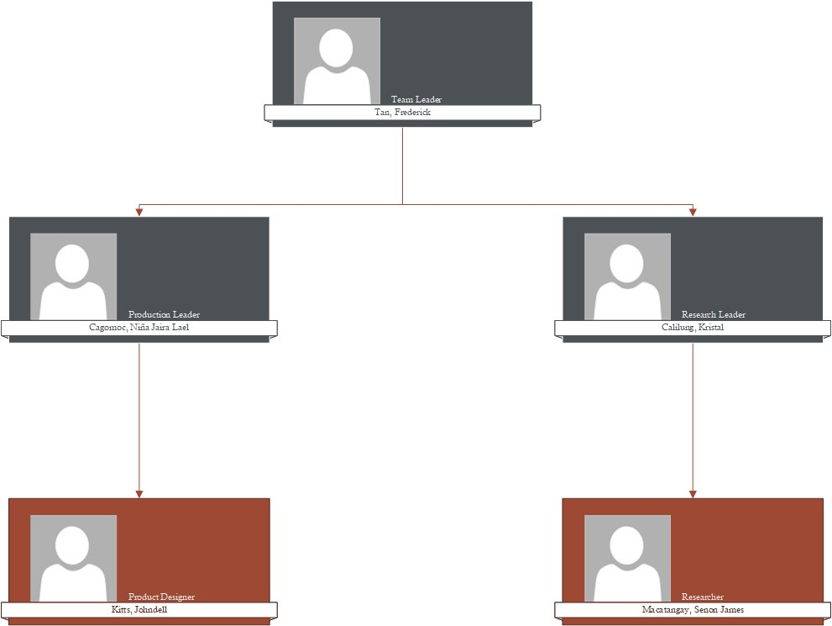

1. **TIMELINE:** *(Milestones for expected completion by phase)*

* 1. **MILESTONES OF THE PROJECT** 
     + - First meetings - (April 20 - April 26)
       - Brain Storming - (April 20 - May 4)
       - Planning and initial Document Drafting - (April 27 - May 4)
       - Document Revisions - (May 4 - June 24)
       - Research and Development - (May 4- June 24)
       - Project estimating - (May 5 - May 18)
       - Project Material Canvassing - (May 20 - May 31)
       - Marketing Introductory -(May 31 - June 10)
       - Budgeting and Costing - (May 31 - June 15)
       - Production planning - (May 31 - June 24)
       - Material Acquisition - (June 30 - July 10)
       - Material Testing - (June 30 - July 10)
       - Finalization of Document - (June 24 - June 29)

* + - * Production and Manufacturing Execution - (July 1 - July 12)
      * Assembly of Circuit Module - (July 1 - July 12)
      * Assembly of whistle - (July 1 - July 12)
      * assembly of Flashlight - (July 1 - July 12)
      * Final Assembly Phase - (July 10 - July 12)
      * Product release - (July 12 - July 13)

* + - * Coding of source code to Arduino - (June 27 - June 30)

* + - * Flow Chart - (May 31 - June 10)
      * Schematic Diagram - (May 31 - June 10)
      * Creating Blueprint - (June 15 - June 30)

* + - * Product Sampling and Testing (June 15 - June 21)
      * initial Testing - (June 15 - June 18)
      * Quality Testing - (June 19 - June 21)
      * Final Testing - (June 22 - June 24)

* 1. **WORK BREAKDOWN STRUCTURE (WBS)**

1. **SIGN OFF:** *(Signature of key sponsors, subject matter expert heads)*

|  |  |  |  |
| --- | --- | --- | --- |
| Name | Position | Signature | Date Signed |
| Cagomoc, Niña Jaira Lael B. | Production Leader |  | 05/31/2022 |
| Calilung Kristal | Research Leader |  | 05/31/2022 |
| Kitts, Johndell S. | Product Designer |  | 05/31/2022 |
| Macatangay, Senon | Researcher |  | 05-31-2022 |
| Tan, Frederick | Team Leader |  | 05/31/2022 |

Project Charter - Page

Project Charter - Page